Microphones for recording
We were looking at omnidirectional bluetooth mic options to be used with phones. Good options for filming outdoors would be especially helpful!
Recording outside: ideally, you want a windscreen. The nice thing about personal bluetooth microphones / lavalier microphones is that they are close to the subject, and the goal with good sound production in less ideal environments is to create a good signal-to-noise ratio: signal= your voice, noise=wind.
Budget?
$29.99 : wired lavalier microphone for iPhone: https://www.bestbuy.com/site/boya-clip-on-lavalier-microphone-for-ios-devices/6395268.p?skuId=6395268&ref=212&loc=1&ref=212&loc=1&ds_rl=1268655&gclid=CjwKCAjw2dD7BRASEiwAWCtCb4k5vWXfV9zS-_1VEOMvYGbRgvtE6qKr6tAILf9S1PXHrLN7EeWDHhoCz78QAvD_BwE&gclsrc=aw.ds
Wired is superior in some ways because you don’t have to worry about wireless signal interference. I’ve had bad wireless lav mics before where you get a “snow” sound on your recording. But they weren’t Bluetooth; they were using a different radio technology. Wired is definitely going to be cheaper.
Any wired lavalier microphone that uses a 3.5mm stereo jack: you can buy an adapter for your phone. For example, iPhone users would need:
https://www.amazon.com/Apple-Lightning-Headphone-Jack-Adapter/dp/B01LXJFMGF
Android users would need:
Your 3.5mm headphone port might actually be a headphone/mic port. It depends on your phone model.
$39.99 : just your standard bluetooth headset / earpiece: https://www.amazon.com/Bluetooth-Wireless-Earpiece-Cancelling-Compatible/dp/B07HBTYBMB
Big caveat: in my work, I don’t typically use devices like this for audio recording, so my recommendations are plausible, based on reading, but untested. I typically use field recorders like:
Zoom H2n: https://zoomcorp.com/en/us/handheld-recorders/handheld-recorders/h2n-handy-recorder/

Audio editing
Especially equalizing audio quality across clips filmed in different spaces (WavePad is an additional audio software that goes with VideoPad, but it's an additional purchase and I'd be curious to hear of any first hand experience or recommendations for it)
I have used VideoPad but have not used WavePad. Audio normalization, i.e. equalizing audio quality across clips, is so important. They say that you can forgive problems with video production and fix them more readily in post-production, but problems with audio production are distracting and difficult to fix. Good audio depends a lot on your initial recording results, so let me talk about that first.
Thinking through: ambient noise, how close you are to your microphone, your microphone’s gain settings, your microphone’s recording mode, etc.
Ambient noise: if you have to record outside, fine, but perhaps choose a day with light wind. Also, think about:
- Refrigerator compressors
- Dishwashers
- What is your housemate schedule? Don’t start recording 5 minutes before your kids come home from school!
- If you are using a field recorder, you can plug in a pair of headphones and just listen to what the microphone hears.
Microphone gain settings: if you’re using a microphone with your smartphone and you’re using a recorder app like “Voice Recorder” on Android or “Voice memos” on iPhone, most likely, the app is managing your gain settings for you. “Gain” is recording volume or recording amplification.
Microphone recording mode: this doesn’t apply if you are using a lav mic or Bluetooth earpiece because it has one recording mode: omnidirectional. Otherwise, if you are using a Zoom H2n, Tascam, Blue Yeti, or others, it may have the ability to switch between cardioid, omnidirectional, bidirectional, etc. Use cardioid to minimize ambient noise if there is only one person speaking, and speak directly into the microphone (with a windscreen) from a distance of at least 8 inches. Omnidirectional is for when you can’t predict the direction of sound, and it comes with more risk for ambient noise.
That being said: let’s talk about audio normalization.
If you make different recordings on different days and pull these clips together, you may have audio levels going up and down. I like to fix this in my video editor such as iMovie.
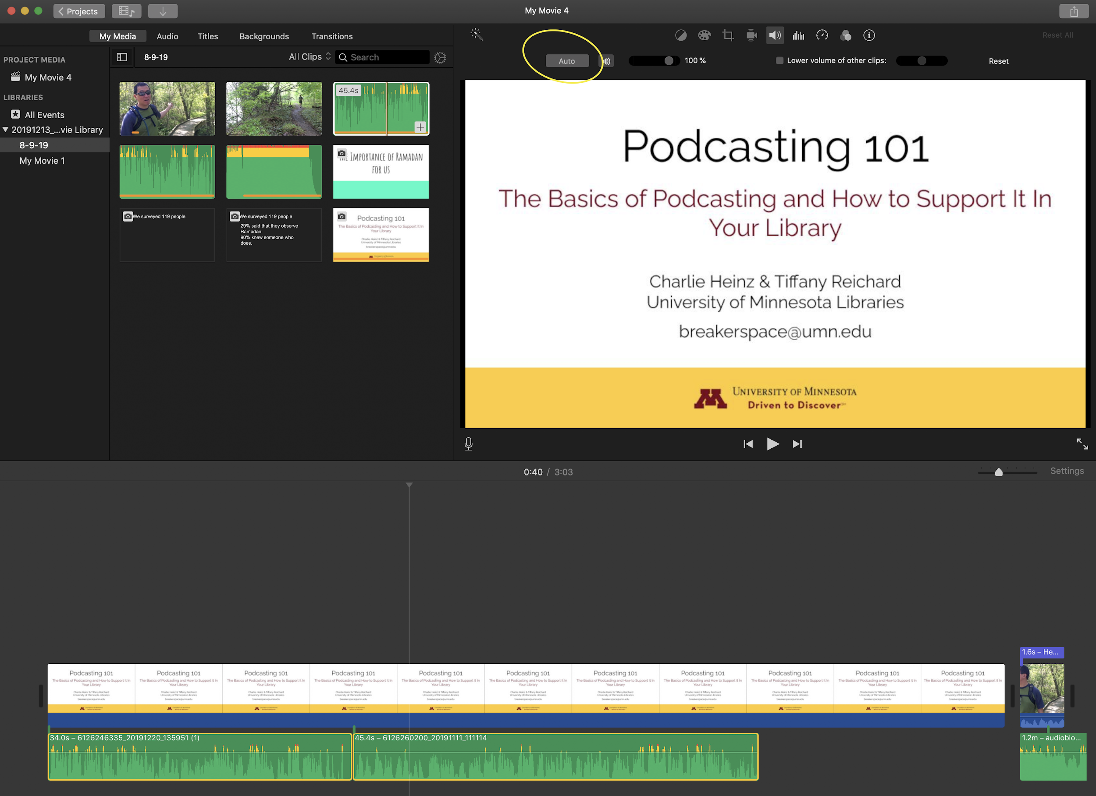
Select two clips and click “Auto”.
You can also do this manually in Audacity, but this is a bit harder to learn how to do well.
This will fix audio levels going up and down. But in terms of differences in quality, that’s a little bit different. If you record on one day with one microphone, and then you record a different segment on a different day with a different microphone, inevitably, your recordings will have a different quality or “character”. Making two recordings sound characteristically the same is a question for an audio engineer, and I don’t have that skill level. Instead, I just try to replicate my conditions as best as possible if I want different clips to sound similar in character. Or get all of my audio recording done in one setting.

Any other ideas for stabilizing/optimizing filming when outdoors
- And especially when moving around (i.e. filming a moving process like planting or checking on a beehive)
- We are currently thinking of youtube videos for our outreach. I think youtube has some video editing capabilities, but I'm primarily using imovie by pulling the videos to my ipad.
See smartphone tips: https://youtu.be/AfRL2xDdN8A
If you’re using your phone, make sure you have enough space on your phone. Personally, I only have about 1.5 GB left on my phone, so if I start video recording, I’ll run out after, maybe, 20 minutes.
Moving around can mean shakiness. Professional videographers would use a body gimbal:
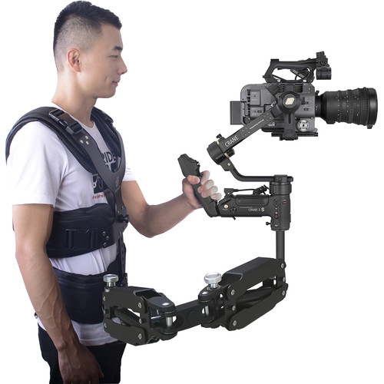
How about a selfie stick instead?
https://www.amazon.com/Selfie-Extendable-Detachable-Wireless-Remote/dp/B082YQTQPC/ref=asc_df_B082YQTQPC/?tag=hyprod-20&linkCode=df0&hvadid=416748412703&hvpos=&hvnetw=g&hvrand=780924418185241167&hvpone=&hvptwo=&hvqmt=&hvdev=c&hvdvcmdl=&hvlocint=&hvlocphy=9019659&hvtargid=pla-890440281585&psc=1&tag=&ref=&adgrpid=95587149524&hvpone=&hvptwo=&hvadid=416748412703&hvpos=&hvnetw=g&hvrand=780924418185241167&hvqmt=&hvdev=c&hvdvcmdl=&hvlocint=&hvlocphy=9019659&hvtargid=pla-890440281585
Just being able to hold it on a pole would help stabilize the recording.
Make sure to keep your smartphone horizontal, not vertical! Unless you’re making a stylistic choice. Otherwise, your video will look like this:
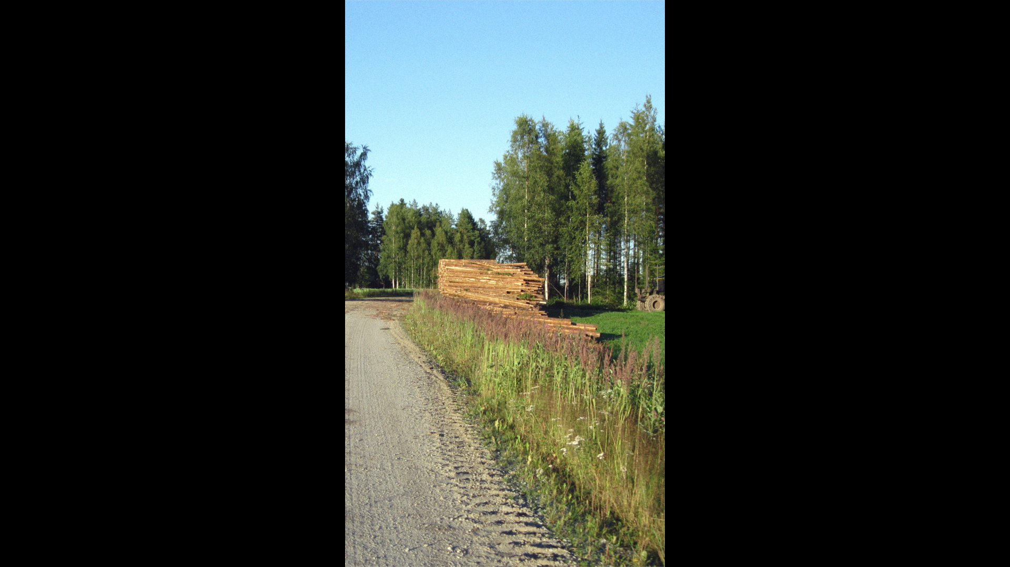
For close-up shots, I would experiment with your smartphone and see how good your auto-focus responds to things changing from far away to close up and far away again. Clean your lens, light and sensors with a dry microfiber cloth before recording.
Smartphones have become really good at mimicking the “depth of field” effect that DSLR cameras have historically been known for.
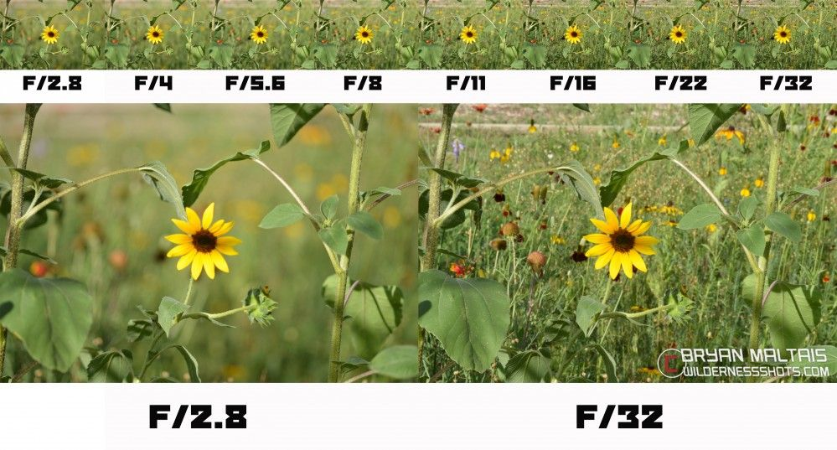
https://www.pinterest.com/pin/45669383700899302/
On the left, the flower is the focal point. On the right, the whole scene is in focus. If you want to draw attention to the flower, the left is what you want.

Youtube
YouTube’s editing tools is good for trimming off bad portions of your clip, but for any compositional video production (compositional: combining different clips, audio, music, transitions, effects…), use iMovie. For Windows, Microsoft Photos is an option. For a whole list of options, see: https://docs.google.com/spreadsheets/d/1ytT2YKa-KVmzDQq019TnlV8DEEivZdkOJ5ub82tSGT8/edit#gid=460426370
I recommend transferring your files off of your iPad to back them up on a second device or in the cloud. Something could happen to your iPad, and that would be really tragic!
Questions:
-Are there other cheap/free video options for student workers to help with?
See: https://docs.google.com/spreadsheets/d/1ytT2YKa-KVmzDQq019TnlV8DEEivZdkOJ5ub82tSGT8/edit#gid=460426370
-Tips and tricks for most engaging videos? (Thanks for sending to overview earlier)
Engagement: think about your audience and your purpose. Is this academic, educational, persuasive? To impress or to be fun?
Let’s say your audience is youth and you want this to be fun and engaging:
- Use humor!
  - Use the Pinch Me example
- Have the narrator be someone who works with kids in your program a lot. They already have a great voice for this work and a lot of experience with keeping kids engaged.
- If you’re telling a story, think about classic narrative structure:
- 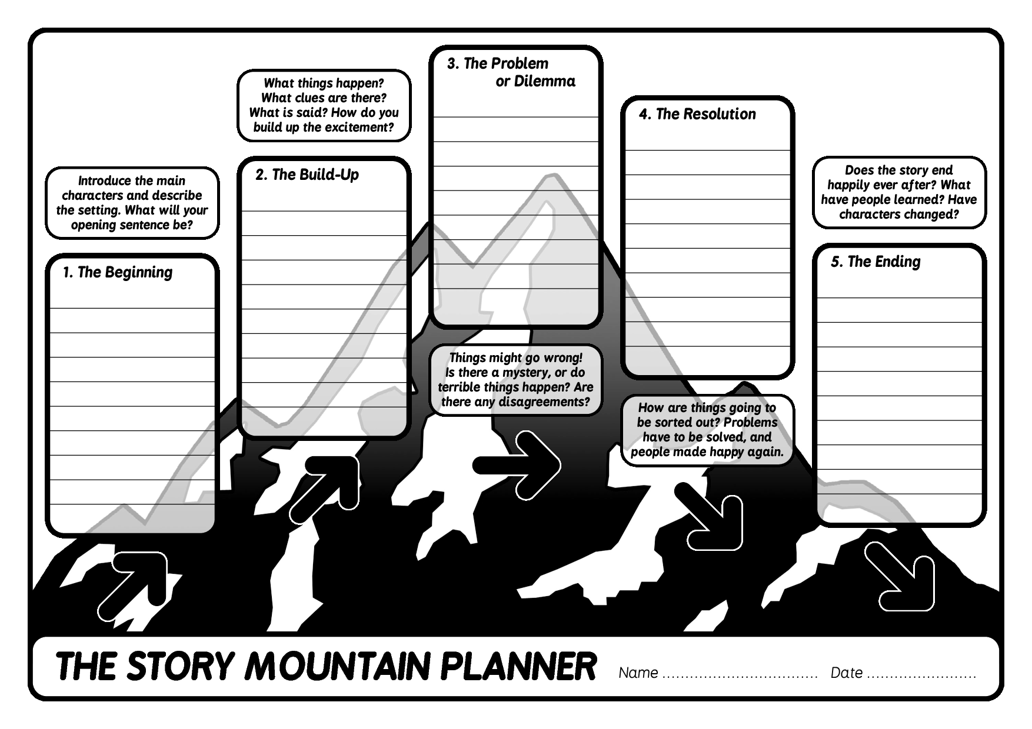
- https://sites.google.com/site/mrsgarza4th/narrative

Recap:
- Using transitions
- Adjusting the audio volume so that it's not at different levels in different segments of the video
- Adjusting the music volume so that you can hear the speaker
- Cutting out segments from the middle of the video
- Adjusting brightness or color correction
- Background noise (wind, dishwasher sounds, lawn mower...)
- Other sound correction (pops, "S" sounds...)
- Adding Closed Captioning for accessibility
- Putting it on YouTube or other media hosting platform
- Finding really nice photos, stock video, or music to use as "B roll" footage
- Storyboarding : if you haven't started yet, it's always a good idea to think ahead about the sequence of events that tell the story. Otherwise, when you go out and record, you might miss some key footage.

-Things to avoid
-Creating B clips
When you record on scene, it’s good to record a minute or so of some silence. You can use this to fill in pauses in the editing stage.
Lots of B Roll can be found at it.umn.edu/stock-content
Google Image search with Usage Rights set to Creative Commons is a good way to find B footage.

-Tips for recording/ creating good content

